Excel and Power BI report

Harnek Singh -502104169  
 Shaurya khanna - 502104123   
 Deepanshu Uppal -502104168   
 Khushbu -502104171

**Introduction**

* The data provided to our team was a cumulative vaccine data for the whole country.
* A four-month window of data was given in the data set.
* Primarily the columns consisted of first dose, second dose, covaxin ,covishied data distributed along all the states

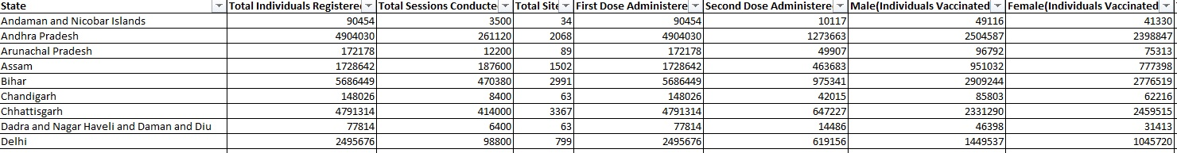A small glimpse of the Data

To get useful sense from the data, we converted the cumulative data by subtracting values from the next cell by previous cell and storing it the in the same cell.

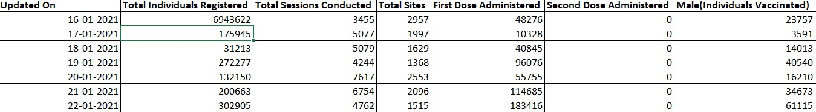

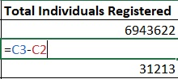

Basic formula to convert cumulative data

* For the ease of working data set for India as a whole state was extracted.
* The time frame of this data set was from 16 January 2021 to 17 April 2021.

**Conversion to Date Format**

Date was coming in General Format, simply converting it to short date was not working for the whole data.

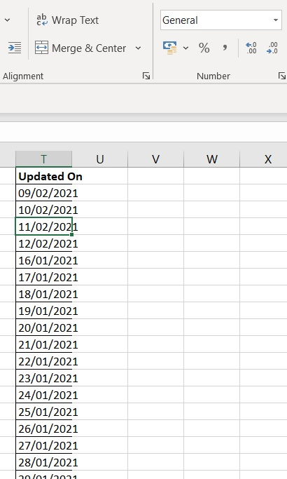

Solution to this problem was using text to columns

Function used-Delimiters

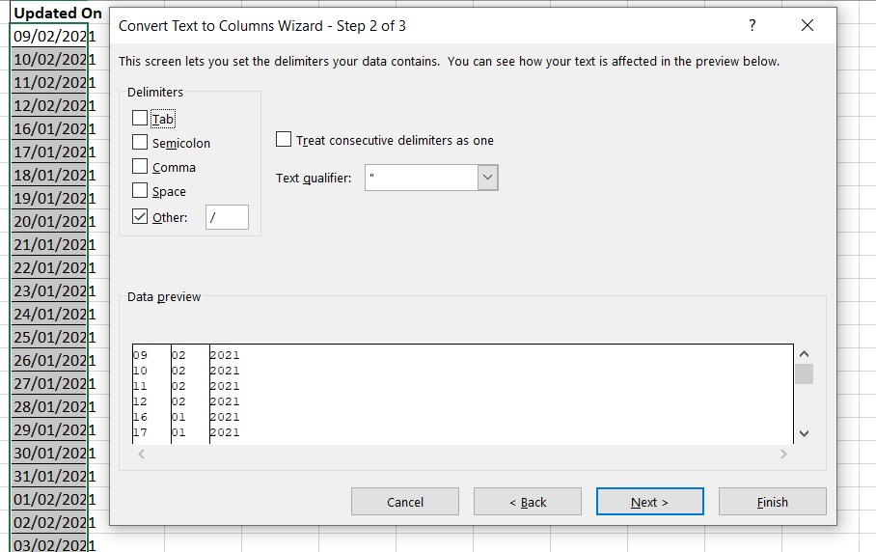

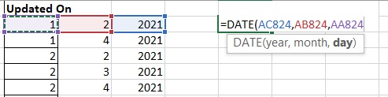

After using Delimiter, the custom date is disintegrated into three columns.

Now the normal Date Function is used to convert it into the date format.

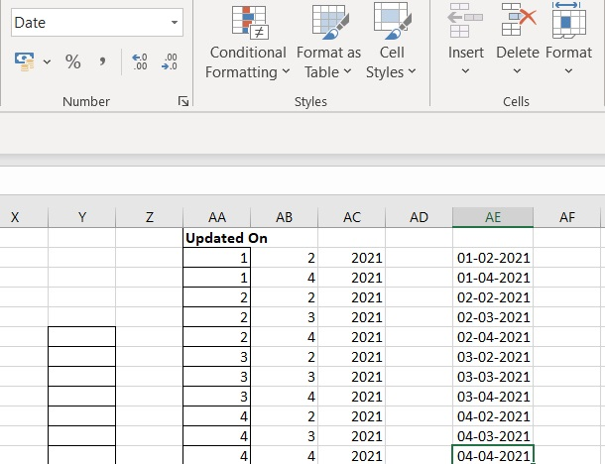

Now the Updated Column is converted to Date format, which can now be used for analysis.

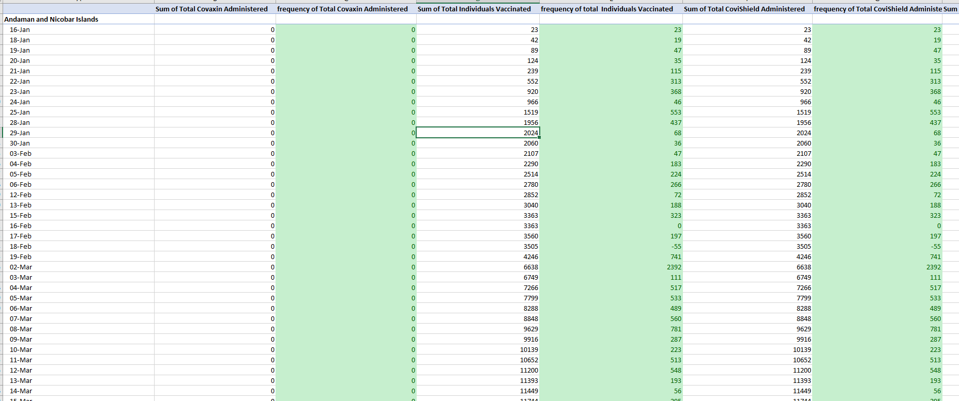**NORMAL Frequency arranged according to states using pivot table**

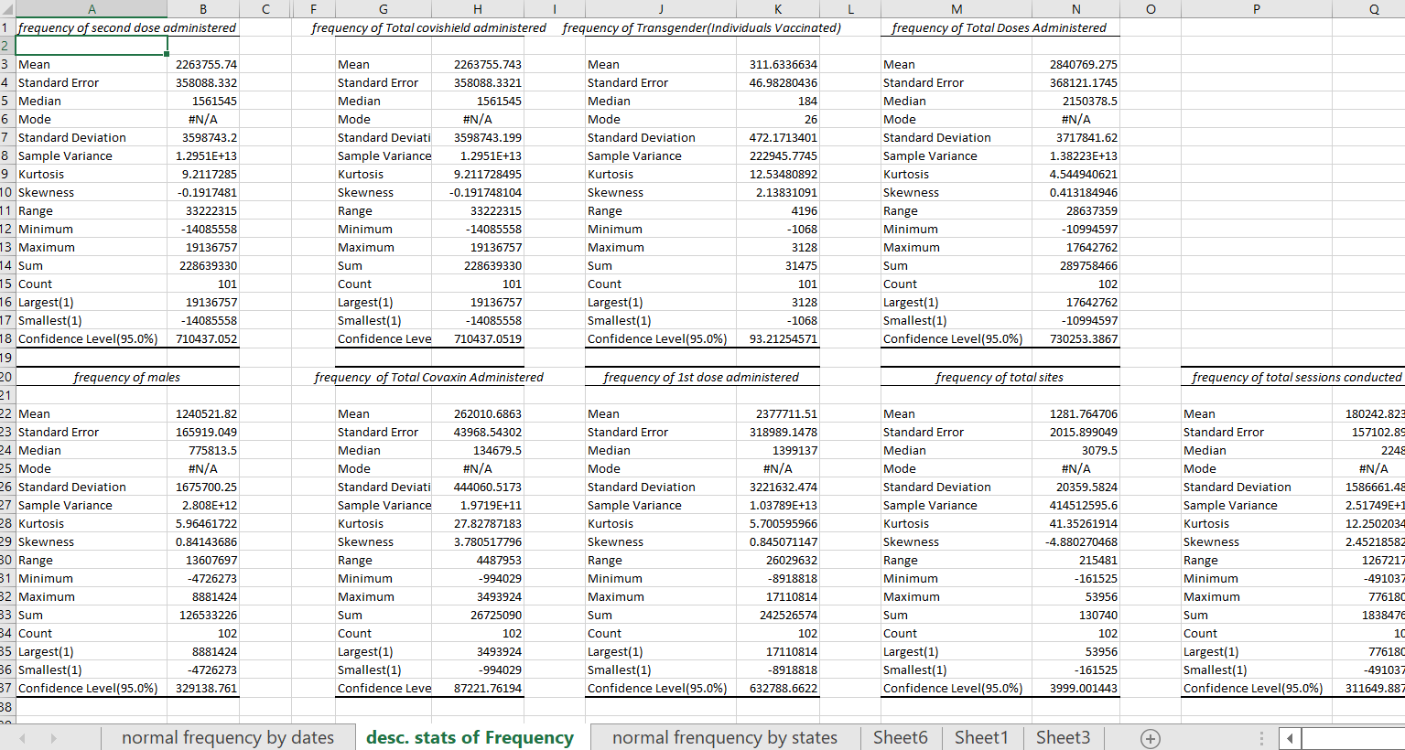**Descriptive statistics of normal frequencies using data analysis tool pack**

**Graphs and Charts for the Data set (India)**

**Using for Forecast Function to predict values for next 10 days**

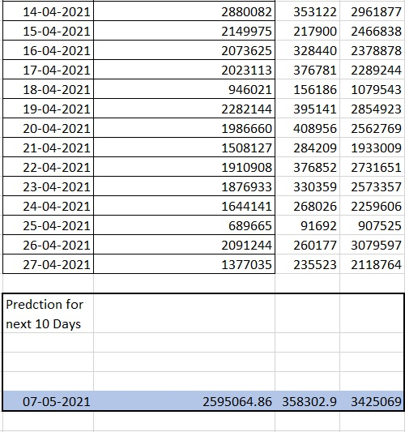

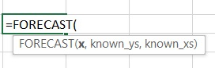

**X= date we want to predict value for. Eg – 07-05-2021**

**Known_ys= Total Individual Registered**

**Known_xs= Updated on**

**Graphical Evidence to support Forecasted Values**

2500000

* The trendline in orange colour predicts the value after 10 days to be around 2500000.
* The value coming from formula is 2595064

* The trendline in orange colour predicts the value after 10 days to be around 350000.
* The value coming from formula is 358302

350000

* The trendline in orange colour predicts the value after 10 days to be around 3500000.
* The value coming from formula is 3425069

350000

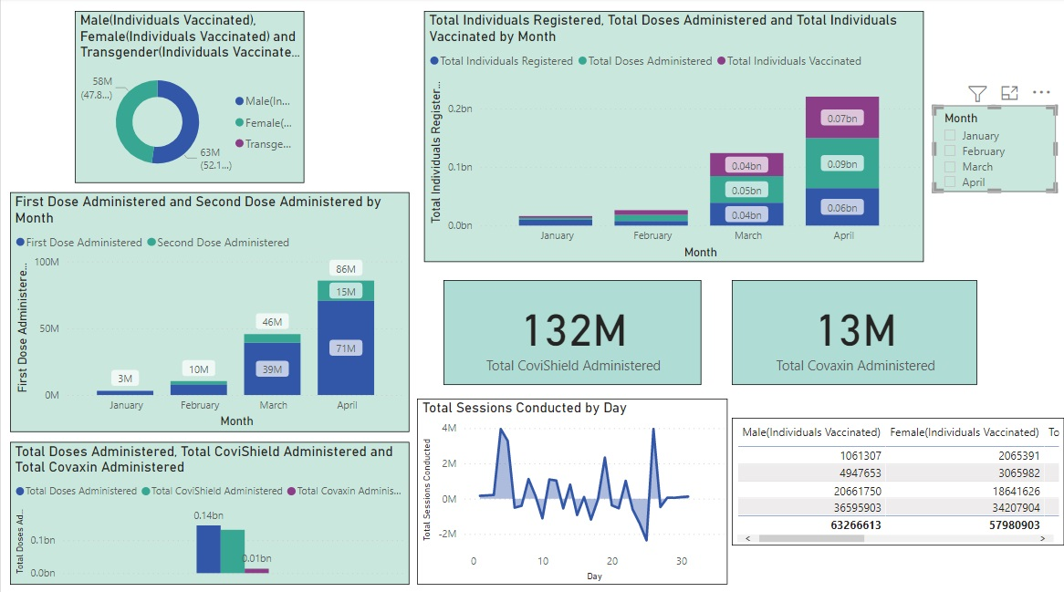**Power BI Dashboard**

**Dashboard for data considering India as a whole country**

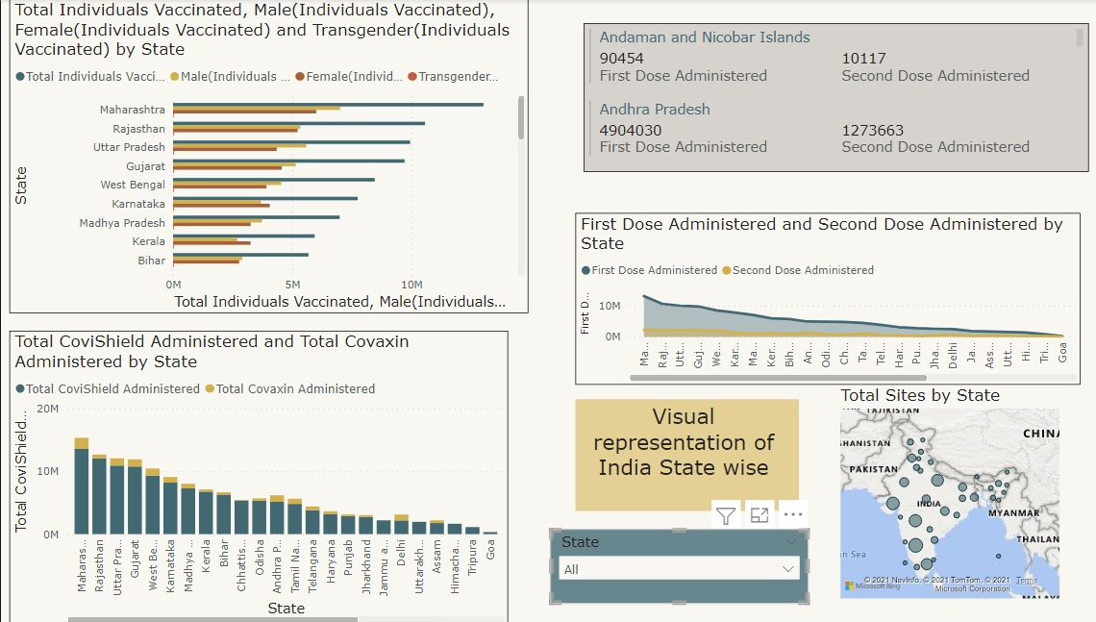

**Dashboard for states**